Irfan Ahmed
ICP 8
Due Date: 10/19/2020 (But I asked for extension due to family emergency, which was approved.)
Explanation on adding more layers:
There are pros and cons to adding additional layers. The only way to know what will work best is to try it out. By adding more layers, I did not see a significant improvement in my output. In theory the more convolutional layer a model contains the slower it will be, but by adding more kernels per layer can help mitigate the slower process and using GPU to speed things up. After adding more layers one problem I encountered was my output for decoder did not match my input for encoder. One of the ways to fix this issue is by adjusting the strides variable. The stride argument was set to 2 but after playing around with random numbers for each layer in the decoder cell, I was able to match the input and output to 28 X 28 X 1. But by adding the additional layer and changing the stride value my output did not come out that great. The output was not that great which did not make too much of sense. Stride is often used for down sample the output channel. To fix this problem after adding additional layer I opted to using the cropping method to make sure my input and output matched so I could run train and compile my data.

  - What you learned in the ICP
One of the main take ways for this ICP was understanding how Autoencoders work. Autoencoders is a feedforward neural network where the input is the same as the output. The input is compressed into a lower dimensional code and then the output is reconstructed from this representation. To build the autoencoder model we need to define the encoding method, decoding method, and a loss function which compares the output with the target. The three components are encoder, code, and decoder. The encoder produces the code, the decoder reconstructs the input. One important thing to note about Autoencoders is that they are data specific, meaning they can only compress data like what Autoencoders have been trained on. Also, the output will not be the same as the input, rather a degraded representation. Lastly, it is an unsupervised method since we do not need explicit labels to train on. Variational Autoencoder is just an probabilistic approach.
  - ICP description what was the task you were performing
- Imported the required libraries/packages and loaded data from MNIST dataset
- Reduced the data size to avoid any colab errors. The training data set was from [0:10000] and the test [0:1000].
- The data model configuration variables were initialized, such as img_width, img_heigth, no_epochs, batch size, validation_split, verbosity, latenet_dim and num_channels.
- The data was reshaped based on the input train shape and input test shape along with the img height and width. The input train and test were Parsed numbers as floats and the test and train normalized.
- The encoder was defined and total of Conv2D layers were created. After each layer it was normalized and at the end.
- Then the shape of the final Conv2D output was retrieved.
- Reparameterization function created
- The reparameterization function was passed into Lambda. This is to ensure that the correct gradient is computed during the backwards pass based on the values for mu and sigma.
- Performed Encoder instantiation (taking inputs through the input layer).
- The decoder was defined with total of 4 Conv2DTransposer layers.
- Performed instantiate decoder. This takes the inputs from the decoder input layer and outputs what the output will by the output layer.
- Created VAE.
- Compiled and trained the data.
- Viewed the outputs as scatter plot and the images.

  - Challenges that you faced
One of the difficulties I faced was figuring out how to add more layers. After figuring that out I encountered another layer which was incompatible shapes. What that meant was my input and output shapes did not match. But after trial and error I found out that I would need to adjust the strides for my decoder. But that did not give me the best result. I ended up using cropping method to obtain the best results.
  - Screen shots that shows the successful execution of each required step of your code
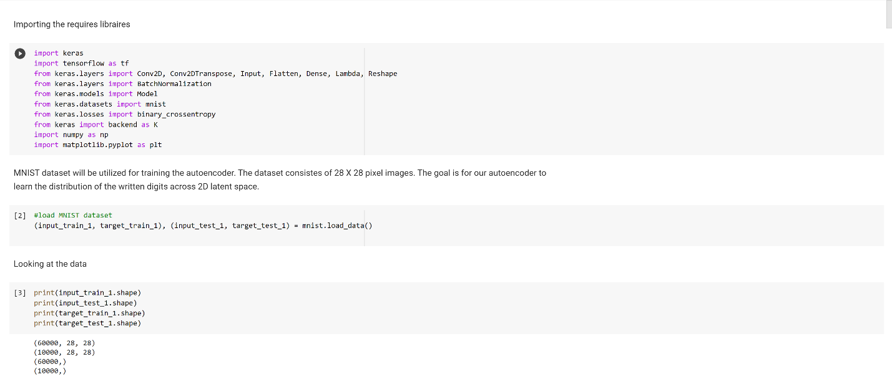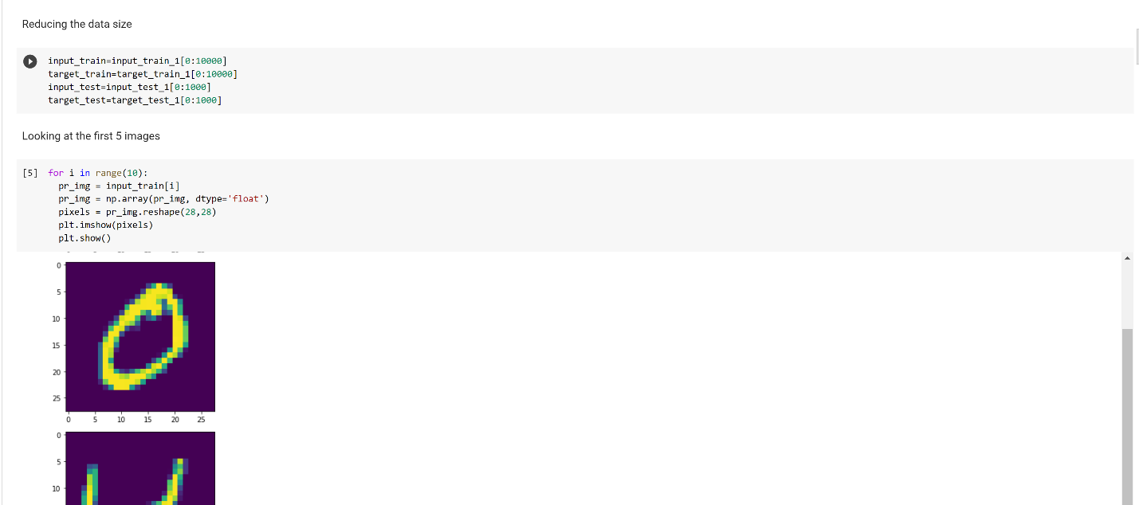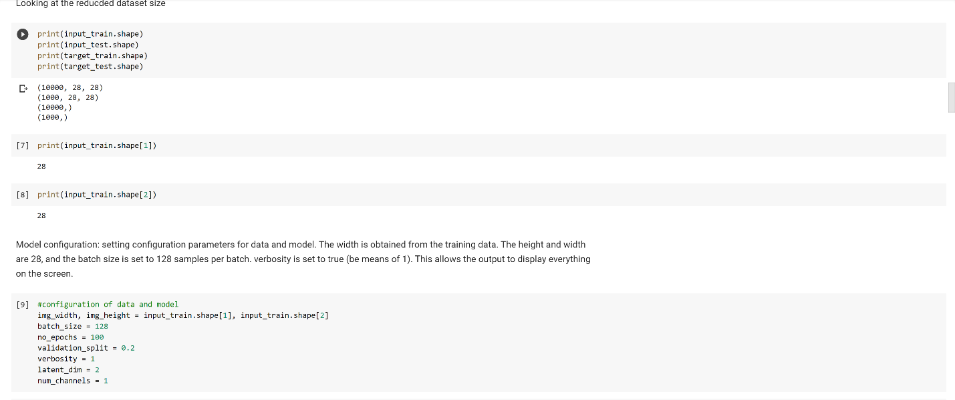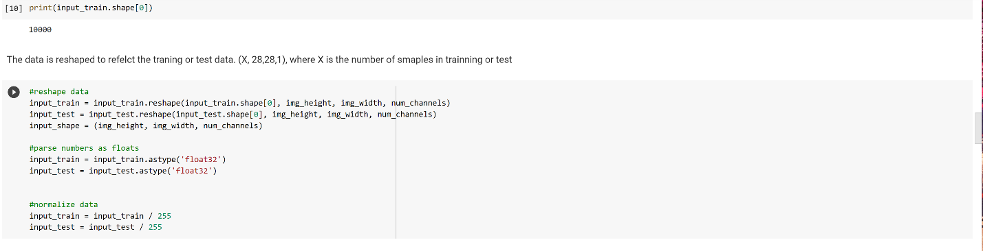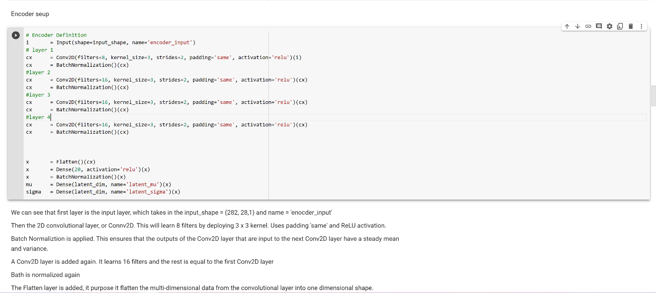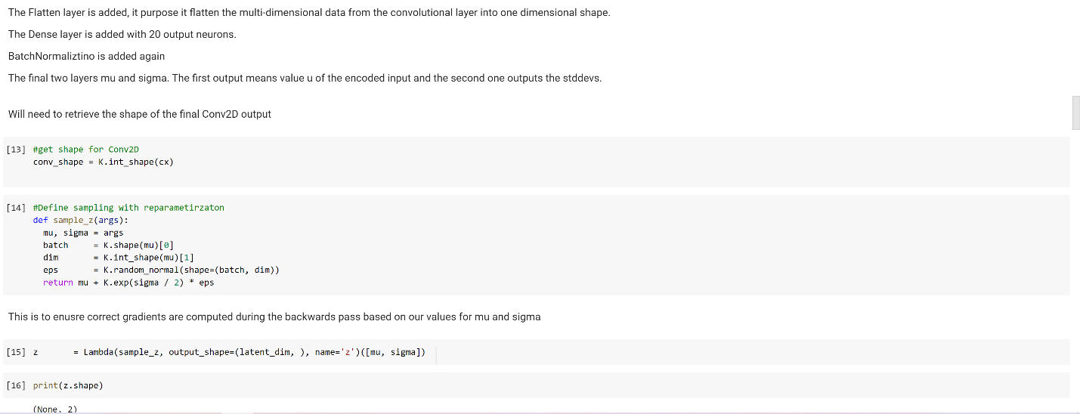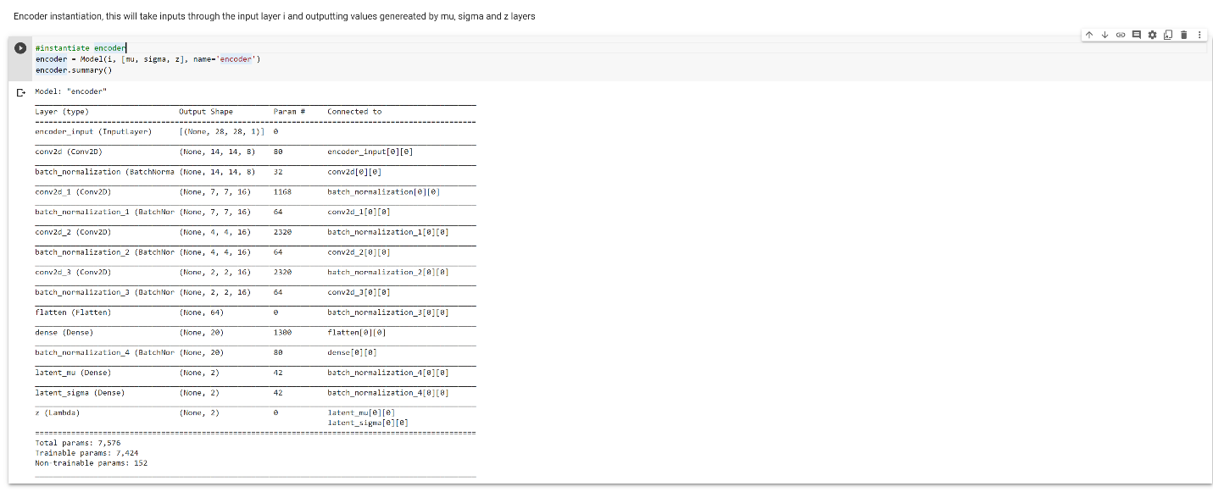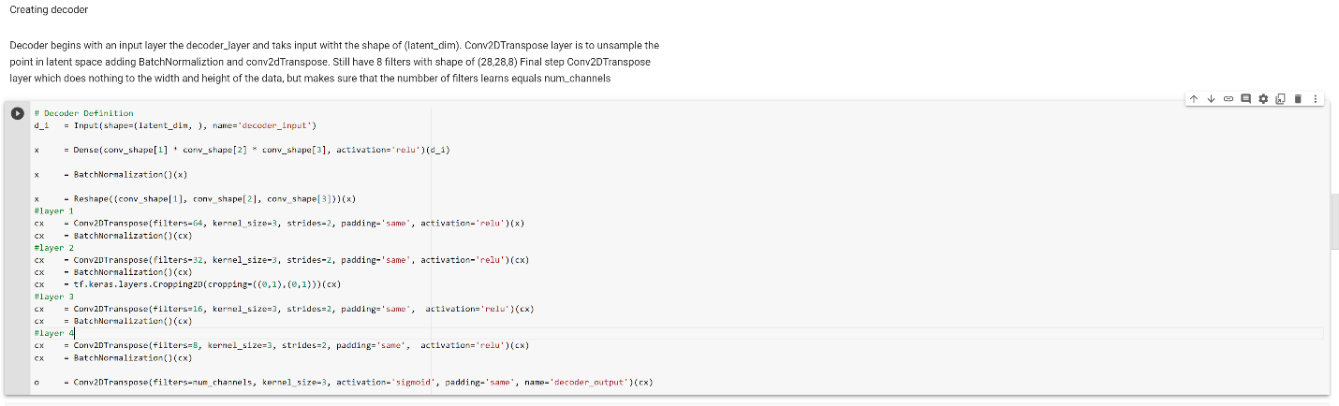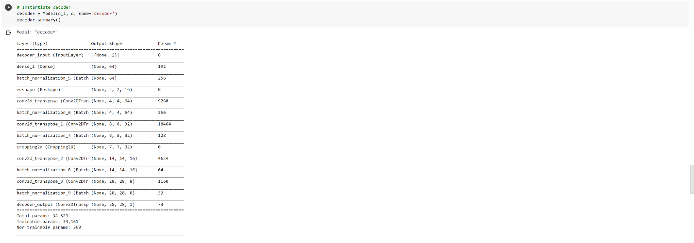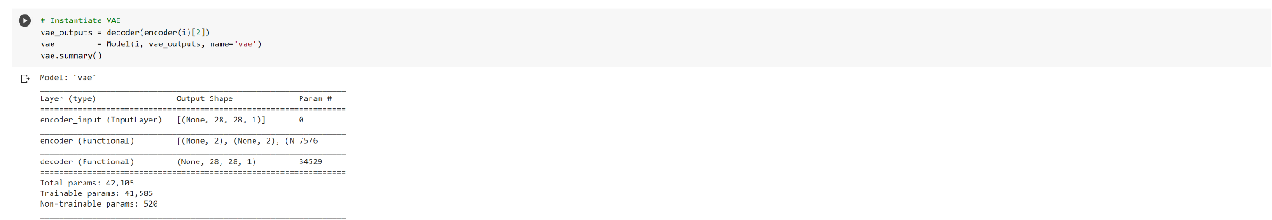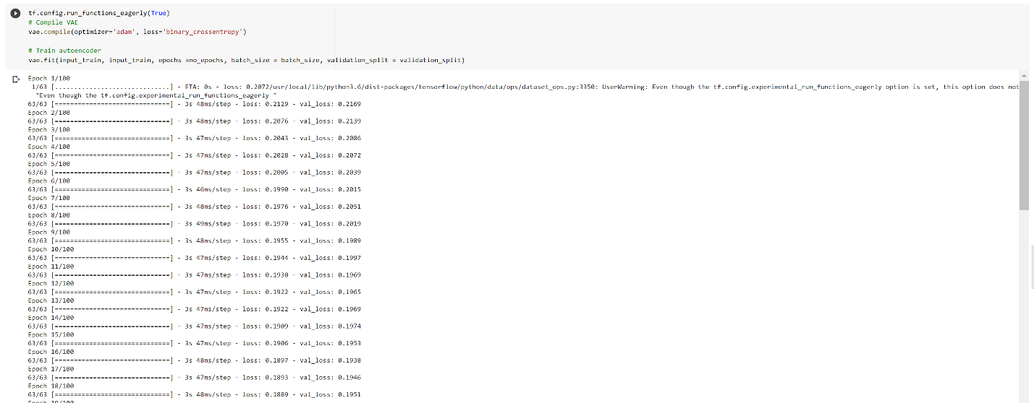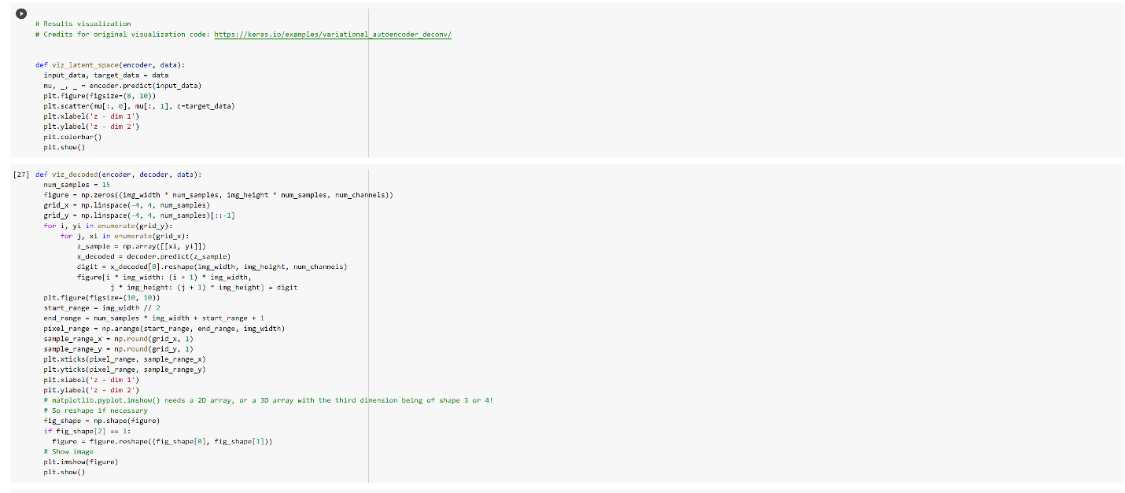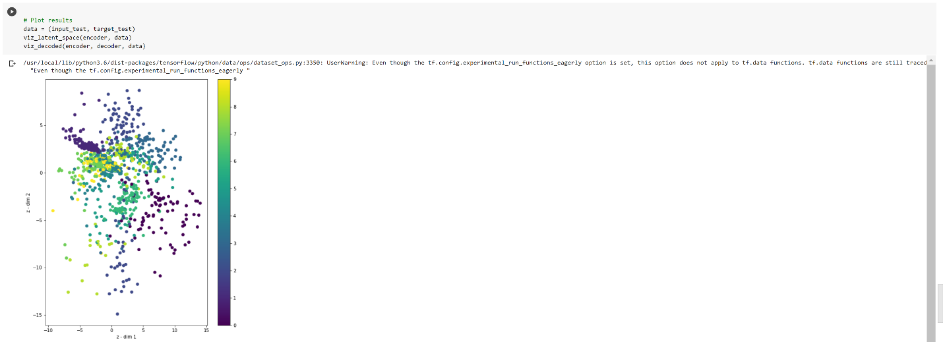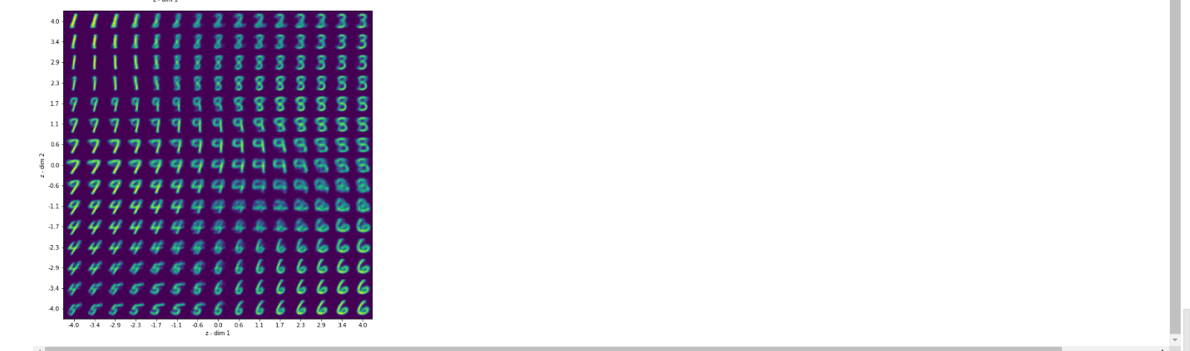

  - Output file link if applicable
https://github.com/UMKC-APL-BigDataAnalytics/icp8-irfancheemaa

  - Video link (YouTube or any other publicly available video platform)
https://umkc.hosted.panopto.com/Panopto/Pages/Viewer.aspx?id=8583ae36-141d-4cb9-bc59-ac5a00572ee7

  - Any inside about the data or the ICP in general
Had hard time explain how the output was affected by adding more layers to the encoder and decoder. Overall, enjoyed the ICP.

